Grade 7 Accelerated · Unit 4 · Lesson 4  Real-World Problems and Significant Digits  Independent Set 4.04 ANSWER KEY | Name  Date  Period

Six questions, on your own, in silence. Show the step that does the work.
1. How many significant digits are in 6,030 grams?
3
The middle zero counts; the trailing zero does not, because no decimal point is written.

2. How many significant digits are in 0.00710 meters?
3
Leading zeros never count; the trailing zero does, because a decimal point is written.

3. A rectangle measures  m by 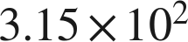 m. Find its area, to the correct number of significant digits.
 square meters
75,600 exactly, kept to two significant digits.

4. 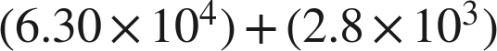 meters, both measured. Write the sum with the correct precision.
 m
63,000 and 2,800 both stop at the hundreds place, so the sum, 65,800, does too.

5. A car travels  km in 4.0 hours. Find its average speed, to the correct number of significant digits.
 km/h
45 exactly; two significant digits.

6. grams, both measured. Write the difference with the correct precision.
 g
0.036155 exactly; 0.037 stops at the thousandths place, so the answer stops there.

